WEEK 5:

Task 5.1:
We are required to create a database and configure a JDBC connection.
So, we first go to the workbench and create a database fsad_db.
Next, in our eclipse spring project we open pom.xml file and navigate to the point where we find <dependencies>.
<dependency>
<groupId>org.springframework.boot</groupId>
<artifactId>spring-boot-starter-data-jpa</artifactId>
</dependency>
<dependency>
<groupId>com.mysql</groupId>
<artifactId>mysql-connector-j</artifactId>
<scope>runtime</scope>
</dependency>

Added these 2 dependencies.
Now, we go to application.properties in order to connect mysql.
Added the following:
spring.datasource.url=jdbc:mysql://localhost:3306/fsad_db
spring.datasource.username=root
spring.datasource.password=12345678
spring.datasource.driver-class-name=com.mysql.cj.jdbc.Driver
spring.jpa.hibernate.ddl-auto=update
spring.jpa.show-sql=true

And spring app shows no error:
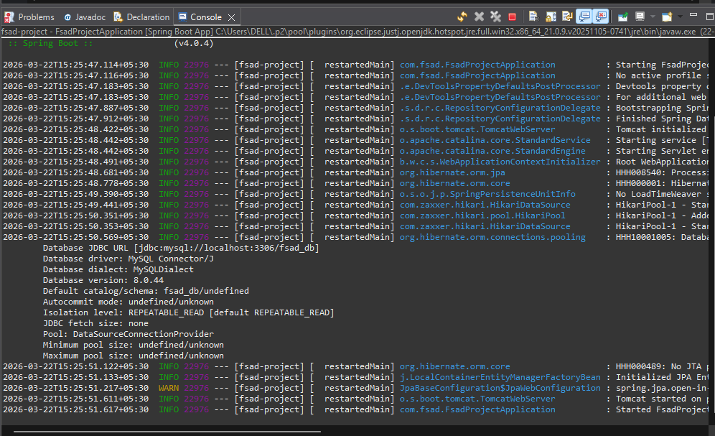

Task 5.2 – Right now our database is empty with no tables or content of any form. JPA (Java Persistence API) let’s us create all this without writing sql queries. So instead of a whole query we just use a few annotations and manage a whole databases’ tables and content.
For this, we create a student table. So, we create:

Student -> class:
package com.fsad;
import jakarta.persistence.Column;
import jakarta.persistence.Entity;
import jakarta.persistence.Id;
import jakarta.persistence.Table;
@Entity
@Table(name = "Student")
public class Student {
@Id
@Column(name="id")
private int id;
@Column(name="name")
private String name;
@Column(name="department")
private String department;
public Student() {}
public Student(int id, String name, String department) {
this.id = id;
this.name = name;
this.department = department;
}
public int getId() {return id;}
public String getName() {return name;}
public String getDepartment() {return department;}

public void setId(int id) {this.id = id;}
public void setName(String name) {this.name = name;}
public void setDepartment(String department) {this.department = department;}

}

NOTE:
Getter -> Since the fields are private, we need a way to let the other classes access the fields. A getter allows selectively chosen other classes to access data in the fields.
Setter -> Setter allows other classes to give or alter the values in the private fields that are otherwise unchangeable.

Thus, when we visit the workbench, we notice that the table “Student” is created without our intervention (Directly):
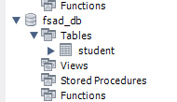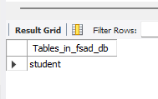

This is ORM -> Object Relational Mapping
This is the translator between java and the database. Thus, we just inform ORM that we need this done and it translates all that into queries that can be executed and the database then has the changes done already. That is ORM.

Task 5.3 - CRUD Application:
The goal of this task is to be able to perform CRUD operations using POSTMAN. Hence we do the following:
- CREATE: add a new student to the database (POST)
-READ: get student(s) from database (GET)
-UPDATE: modify existing student (PUT)
-DELETE: remove a student (DELETE)

To do all these operations, we follow the following steps:
- We create an interface -> StudentRepository: Talks directly to MySQL and we get to do CRUD without querying.
- We create a class -> StudentService: Sits between the Controller and the Repository and contains the logic for the request.
- Create a class called StudentController: This is the thing that communicates and takes care of REST Endpoints.

Postman sends request
→ StudentController receives it
→ calls StudentService
→ StudentService calls StudentRepository
→ StudentRepository talks to MySQL
→ response comes back the same way

Created interface StudentRepository:
package com.fsad;
import org.springframework.data.jpa.repository.JpaRepository;

public interface StudentRepository extends JpaRepository<Student, Integer> {

}

Here, the JpaRepository has built in SQL functions that we can execute using its help without any querying.
So that is why we are extending the JpaRepository, telling that we need all its in built CRUD operations functions.
We are saying Student -> Table name where data has to be meddled with.
Integer -> Datatype of the primary key
- save(student) → INSERT into database
- findAll() → SELECT all students
- findById(id) → SELECT where id=?
- delete(student) → DELETE from database

Created class StudentService:
package com.fsad;
import org.springframework.beans.factory.annotation.Autowired;
import org.springframework.stereotype.Service;
import java.util.List;

@Service
public class StudentService {

@Autowired
StudentRepository studentRepository;

public Student saveStudent(Student student) {
return studentRepository.save(student);
}

public List<Student> getAllStudents(){
return studentRepository.findAll();
}

public Student getStudentById(int id) {
return studentRepository.findById(id).orElse(null);
}

public void deleteStudent(int id) {
studentRepository.deleteById(id);
}

public Student updateStudent(int id, Student updatedStudent) {
updatedStudent.setId(id);
return studentRepository.save(updatedStudent);
}

}

Here, we are importing a list because the JPA returns a list of all student details to us, that is the only way we can take it.

Refer to the following if confused about code:
Okay! Line by line:

import org.springframework.beans.factory.annotation.Autowired;
Importing @Autowired annotation so we can use it 👆
import org.springframework.stereotype.Service;
Importing @Service annotation 👆
import java.util.List;
Importing List — like an array but better. We need it because getAllStudents() returns a LIST of students, not just one!

@Service
public class StudentService {
Telling Spring "manage this class as a bean"

@Autowired
StudentRepository studentRepository;
Asking Spring "give me the StudentRepository bean you created, I need it!" — field injection.

public Student saveStudent(Student student) {
return studentRepository.save(student);
}
Someone gives us a Student object → we tell repository → "save it to database" → return the saved student back

public List<Student> getAllStudents() {
return studentRepository.findAll();
}
Tell repository → "get ALL students from database" → return them as a List

public Student getStudentById(int id) {
return studentRepository.findById(id).orElse(null);
}
Tell repository → "find student with this id" → .orElse(null) means "if not found, return null instead of crashing"

public void deleteStudent(int id) {
studentRepository.deleteById(id);
}
Tell repository → "delete student with this id" → void means we return nothing back

public Student updateStudent(int id, Student updatedStudent) {
updatedStudent.setId(id);
return studentRepository.save(updatedStudent);
}
We get the new data (updatedStudent) → set the id on it so JPA knows WHICH student to update → save it. In JPA, saving with an existing id = UPDATE not INSERT!

Create StudentController Class:
package com.fsad;

import org.springframework.beans.factory.annotation.Autowired;
import org.springframework.web.bind.annotation.*;
import java.util.List;

@RestController
@RequestMapping("/students")
public class StudentController {

@Autowired
StudentService studentService;

@PostMapping
public Student addStudent(@RequestBody Student student) {
return studentService.saveStudent(student);
}

@GetMapping
public List<Student> getAllStudents() {
return studentService.getAllStudents();
}

@GetMapping("/{id}")
public Student getStudentById(@PathVariable int id) {
return studentService.getStudentById(id);
}

@DeleteMapping("/{id}")
public String deleteStudent(@PathVariable int id) {
studentService.deleteStudent(id);
return "Student deleted successfully!";
}

@PutMapping("/{id}")
public Student updateStudent(@PathVariable int id, @RequestBody Student student) {
return studentService.updateStudent(id, student);
}
}

Here, @RequestBody tells about taking the content from the “JSON body”, the content that user enters through forms or other means.
@GetMapping(“/{id}”) means:
So when the user enters something, it goes into the url like:
/student/5
Here, 5 is the id the user entered. So we are telling the mapping to take that id from the url. Same goes for @DeleteMapping(“/{id}”)
Thus, @PathVariable handles the GET part of this from the URL under the mapping.
After all that is done, I tested it by creating a new HTTP request in POSTMAN:
For GET operations:
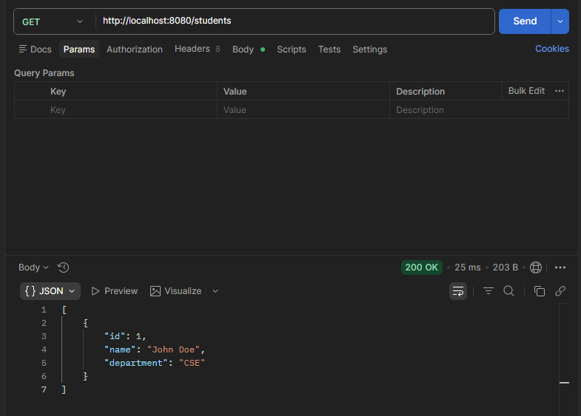
For POST, the same content was entered in JSON body and then that very content is retrieved in GET.
PUT operation: We change the name from John Doe to Jane Doe.
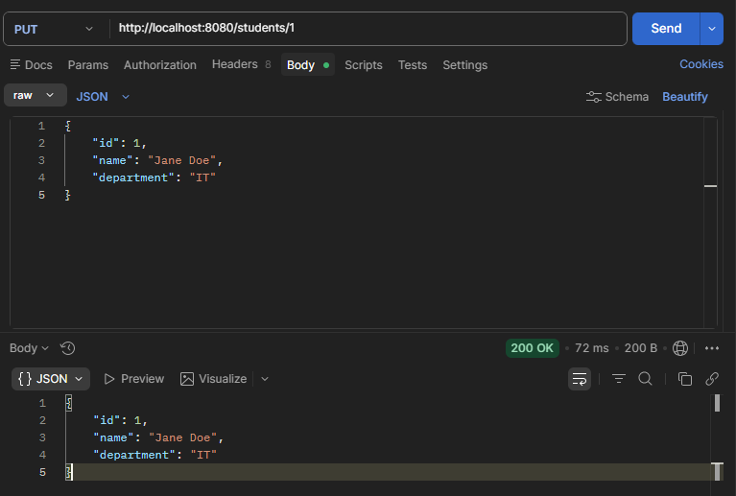

Thus, when we retrieve the data, we see:
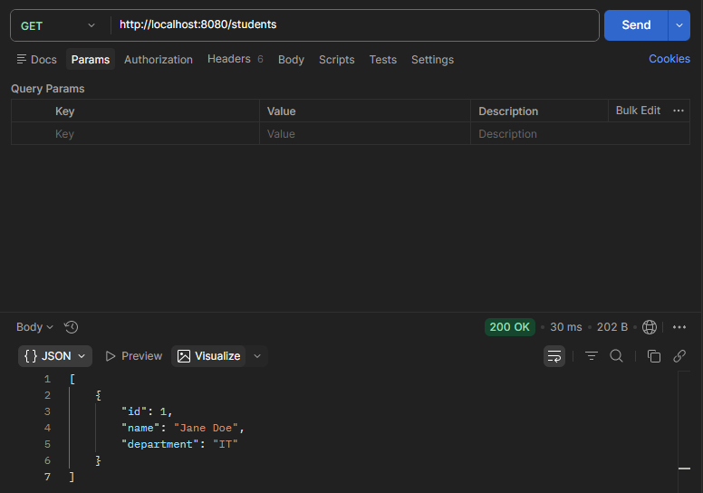
This indicates that the alteration happened successfully.

Finally, DELETE:
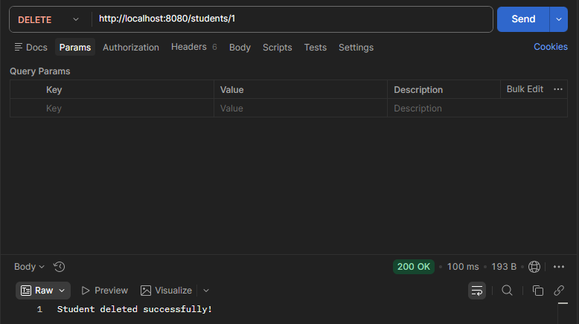
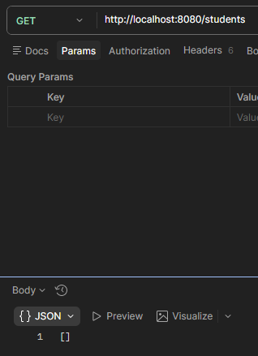 ------------- proves the same, since the GET returned [].

Task 5.4:
Custom Query using JPARepository.
In this thing, we learn that till now we were using default queries given by the JPA. But sometimes we need extra stuff, like, return the names of those kids who scored less than 70. That will be done in this task – again, without using the regular SQL query!
Now, added:
List<Student> findByDepartment(String department);
List<Student> findByName(String name);

To StudentRepository interface.
This tells the JPA to autogenerate query to find a field by its department/name respectively. But the query, we don’t have to write, it gets generated by itself.
Similarly, in StudentService:
Add these few lines:
public List<Student> getStudentsByDepartment(String department) {
return studentRepository.findByDepartment(department);
}

public List<Student> getStudentsByName(String name) {
return studentRepository.findByName(name);
}

Now, lastly, in StudentController we add:
@GetMapping("/department/{department}")
public List<Student> getByDepartment(@PathVariable String department) {
return studentService.getStudentsByDepartment(department);
}

@GetMapping("/name/{name}")
public List<Student> getByName(@PathVariable String name) {
return studentService.getStudentsByName(name);
}

These are the Endpoints for the changes we have just made.
Since all these changes are made, let us try using these and testing POSTMAN.
First, we added:
{
"id": 1,
"name": "John Doe",
"department": "CSE"
}

{
"id": 2,
"name": "Jane Doe",
"department": "IT"
}

In body through JSON while using POST.
Then we used GET to just get details of students who are from department called CSE:

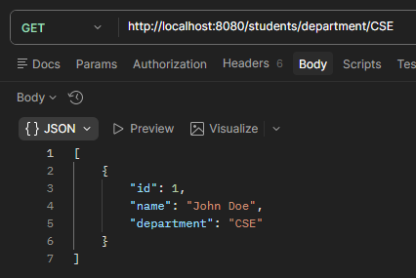

Task 5.5:
Sorting and Pagination:
Instead of getting all the Students at once, we could get them in pages, sorted by a FIELD (Like in google searches. The results are also in different pages, and ordered too).
Hence, we need to do a couple of new imports and additions to StudentService and StudentController:
In StudentController:
import org.springframework.data.domain.Page;
import org.springframework.data.domain.PageRequest;
import org.springframework.data.domain.Sort;
@GetMapping("/paginated")
public Page<Student> getPaginatedStudents(
@RequestParam int page,
@RequestParam int size,
@RequestParam String sortBy) {
return studentService.getPaginatedStudents(page, size, sortBy);
}

In StudentService:
import org.springframework.data.domain.Page;
import org.springframework.data.domain.PageRequest;
import org.springframework.data.domain.Sort;
//and inside the public class StudentService, add the following:
public Page<Student> getPaginatedStudents(int page, int size, String sortBy) {
return studentRepository.findAll(PageRequest.of(page, size, Sort.by(sortBy)));
}

Hence the result:
http://localhost:8080/students/paginated?page=0&size=2&sortBy=name
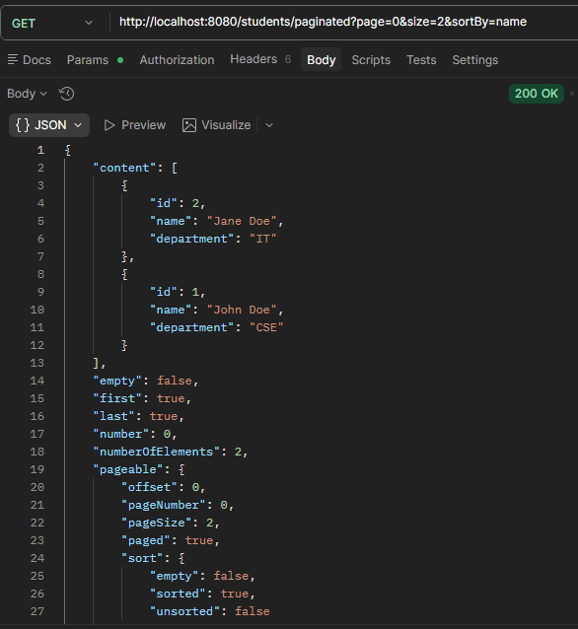
{
"content": [
{
"id": 2,
"name": "Jane Doe",
"department": "IT"
},
{
"id": 1,
"name": "John Doe",
"department": "CSE"
}
],
"empty": false,
"first": true,
"last": true,
"number": 0,
"numberOfElements": 2,
"pageable": {
"offset": 0,
"pageNumber": 0,
"pageSize": 2,
"paged": true,
"sort": {
"empty": false,
"sorted": true,
"unsorted": false
},
"unpaged": false
},
"size": 2,
"sort": {
"empty": false,
"sorted": true,
"unsorted": false
},
"totalElements": 2,
"totalPages": 1
}
-------------------------------------------------------------------------------------------------------------------------------------

